UkrPoshta registration

Created on May 2, 2018 (only the creation of an account is described).

1. To register an account, please follow the link <https://ukrposhta.ua/en/login/>.

2. Click the "Registration" button.

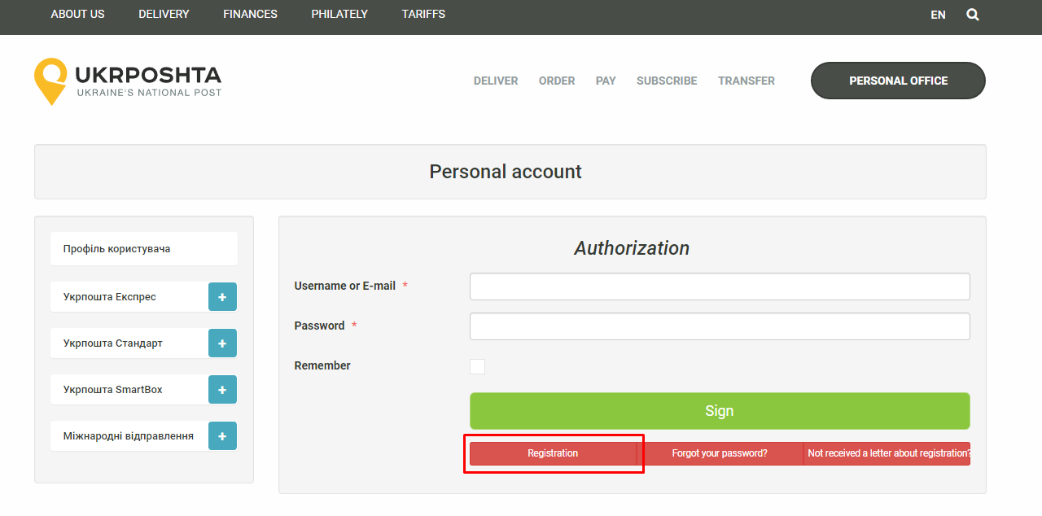

3. In the form that opens, specify the required data and click on the "Send" button.

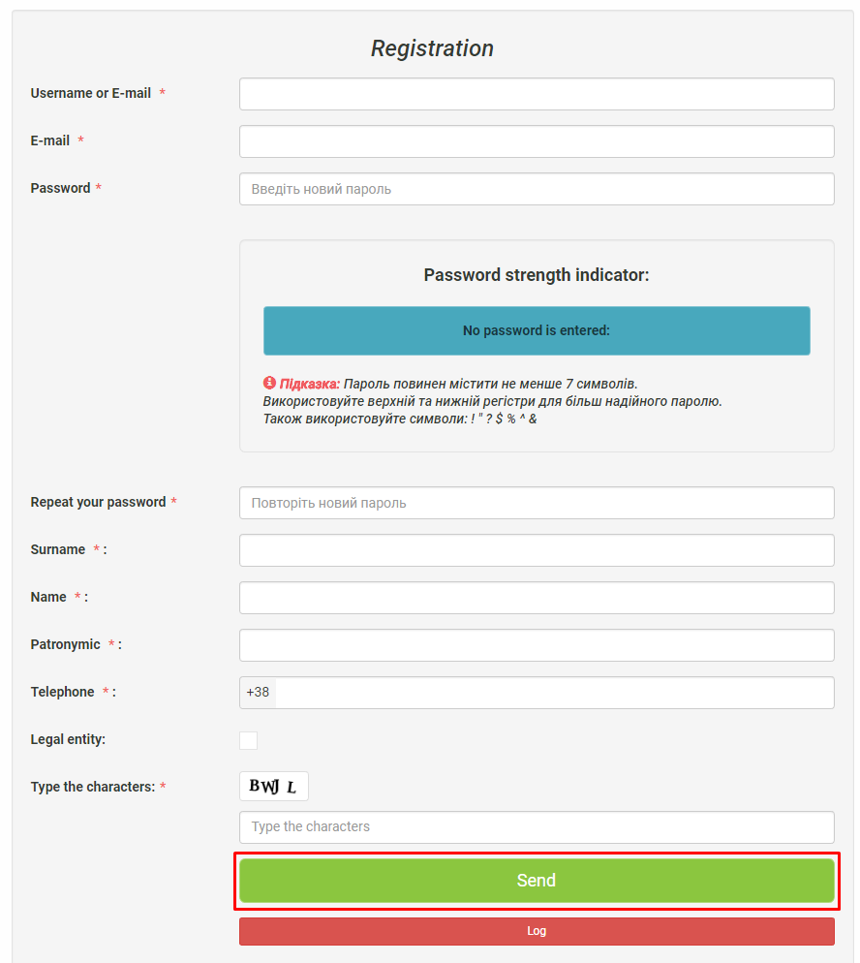

4. After sending the data, confirm the registration via e-mail.

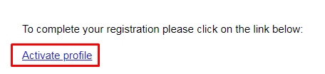

5. Then you will be redirected to the login page. Specify your login and password and click on the "Sign" button.

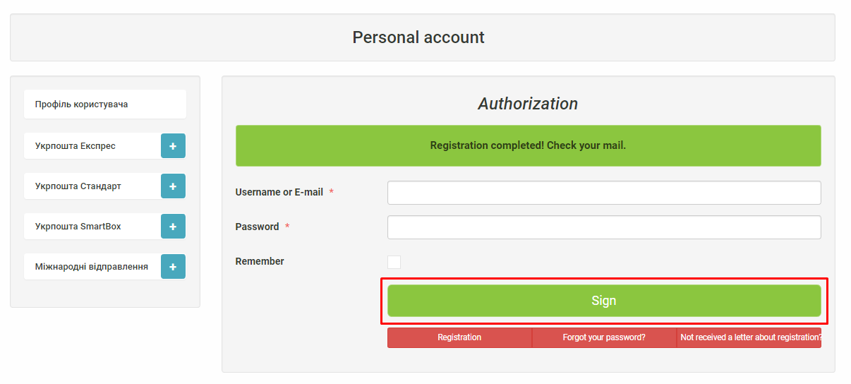

6. Registration is completed successfully.

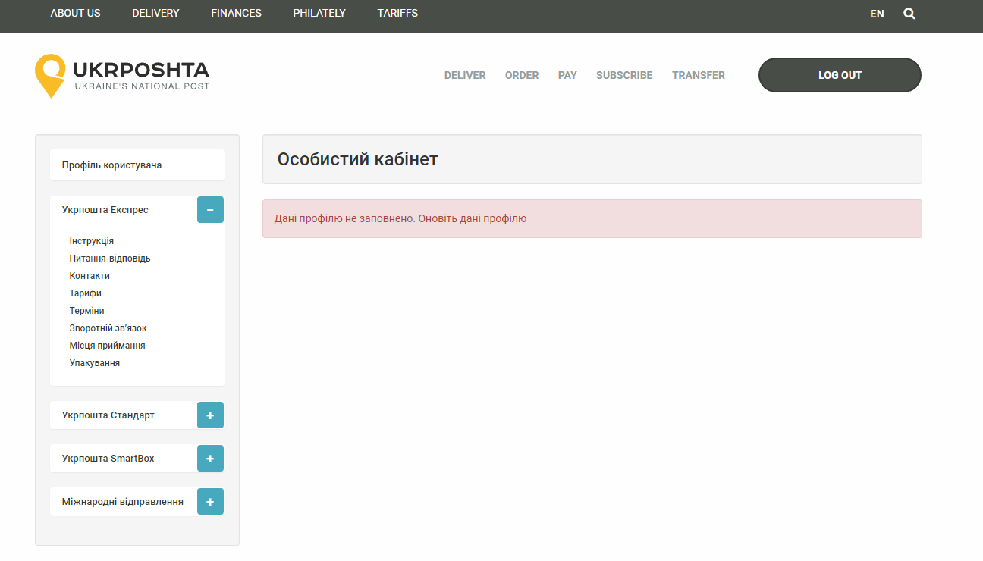

7. To receive the Client ID and Client Secret, contact the UkrPost administration.